# Motor calculation description

## Flowchart

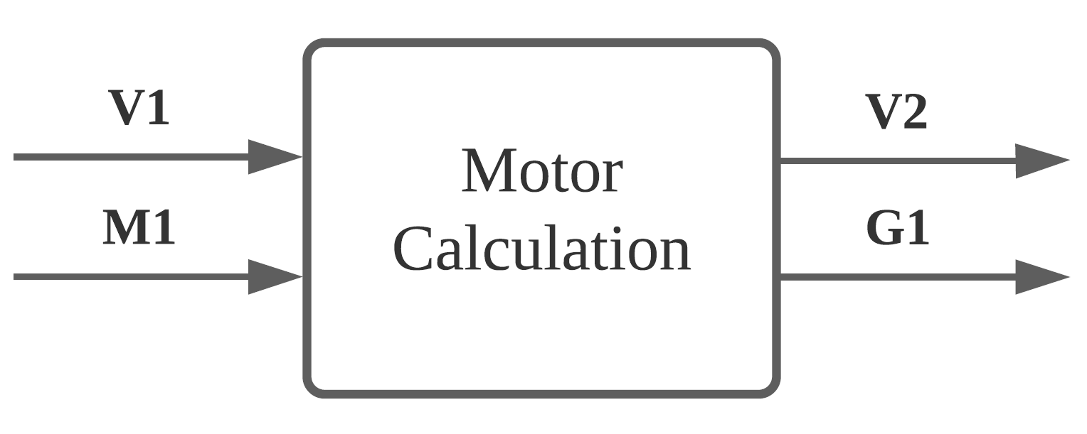

Figure 1 Motor component flowchart

## Unique identifiers

|  |  |
| --- | --- |
| Unique ID | Long Name |
| V1 | Input from user-interface sub-system |
| M1 | Feedback from gearing component |
| V2 | Output to user-interface sub-system |
| G1 | Output to gearing component |

## Table of limits

|  |  |  |  |  |
| --- | --- | --- | --- | --- |
| Interaction | Symbol | Min. | Max. | Unit |
| -> V1 | | | | |
| *Input from user-interface sub-system* | | | | |
| Solar boat velocity | $$V$$ | 0 | 17 | Km/h |
| -> M1 | | | | |
| *Feedback from propellor component* | | | | |
| Torque feedback | $$T_{feedback}$$ | 0 | 3500 | Nm |
| Rotation speed feedback | $$N_{feedback}$$ | 0 | 1000 | rpm |
| <- V2 | | | | |
| *Output to user-interface sub-system* | | | | |
| Power loss | $$P_{Loss}$$ | 0 | 8400 | W |
| <- G1 | | | | |
| *Output to gearing component* | | | | |
| Motor torque output | $$T_{Motor-out}$$ | 0 | 3500 | Nm |
| Motor rotation speed output | $$ω_{Motor-out}$$ | 0 | 2200 | rpm |